LAB 1
Q1: Randomly choose one public dataset and load it in Tableau. Or load the “ABC” dataset.
I’m using the Sample-Superstore.xlsx data provided in the modules.
Loaded data set in tableau.
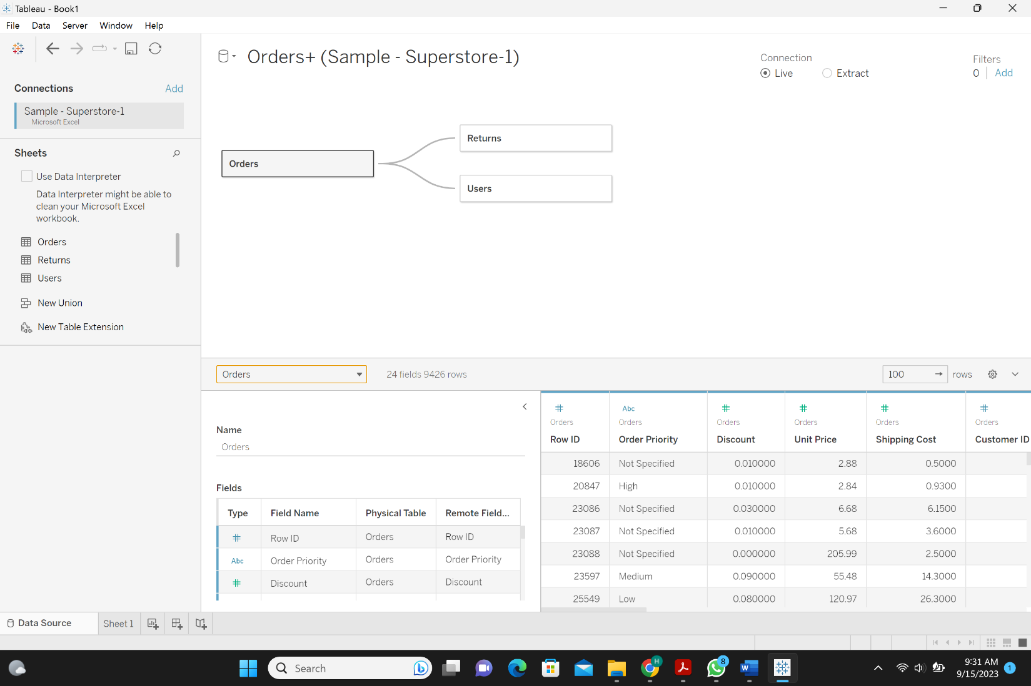

• Q2: Explain/Name all attributes of your selected dataset.
The dataset attributes of the selected dataset are Row ID, Order Priority, Discount, Unit Price, Shipping Cost, Customer ID, Customer Name, Ship Mode, Customer Segment, Category, Sub-Category, Product Container, Product Name, Product Base Margin, Region, State or Province, City, Postal Code, Order Date, Ship Date, Profit, Quantity ordered new, Sales, Order ID, Status, Manager.

• Q3: Use Tableau to generate one “Comparison” visualization graphics and explain.
This graph represents a comparison between the shipping modes of all the sales over time. This is graph helps figure out that regular air delivery has the highest demand then comes the delivery truck in the second place. The express air has the least demand.
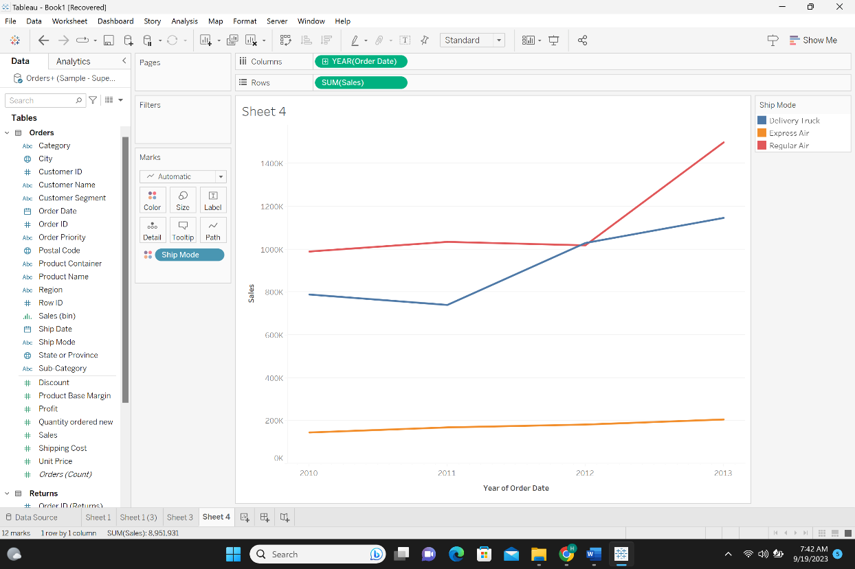
• Q4: Use Tableau to generate one “Distribution” visualization graphics and explain.
This graph is a histogram of the profit and represents a distribution. This graph shows how the profit is distributed over the profit bins. It shows the highest density of profit is in sales with smaller profit.
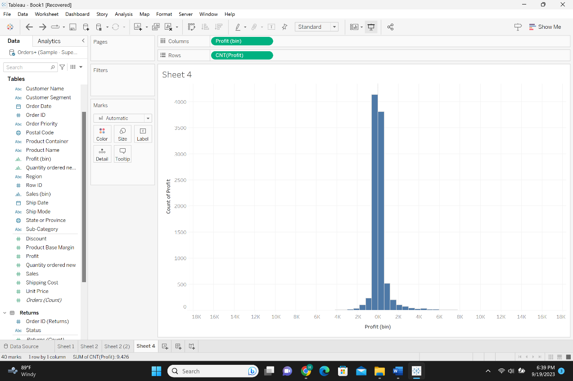

• Q5: Use Tableau to generate one “Composition” visualization graphics and explain.
This is a pie chart showing the simple sales share of each category of total sales. This is why it is a composition based on the lab1 slides. This pie chart shows that the biggest sales portion is in the technology category, in the second place comes office supplies and the smallest portion of sales is for furniture.
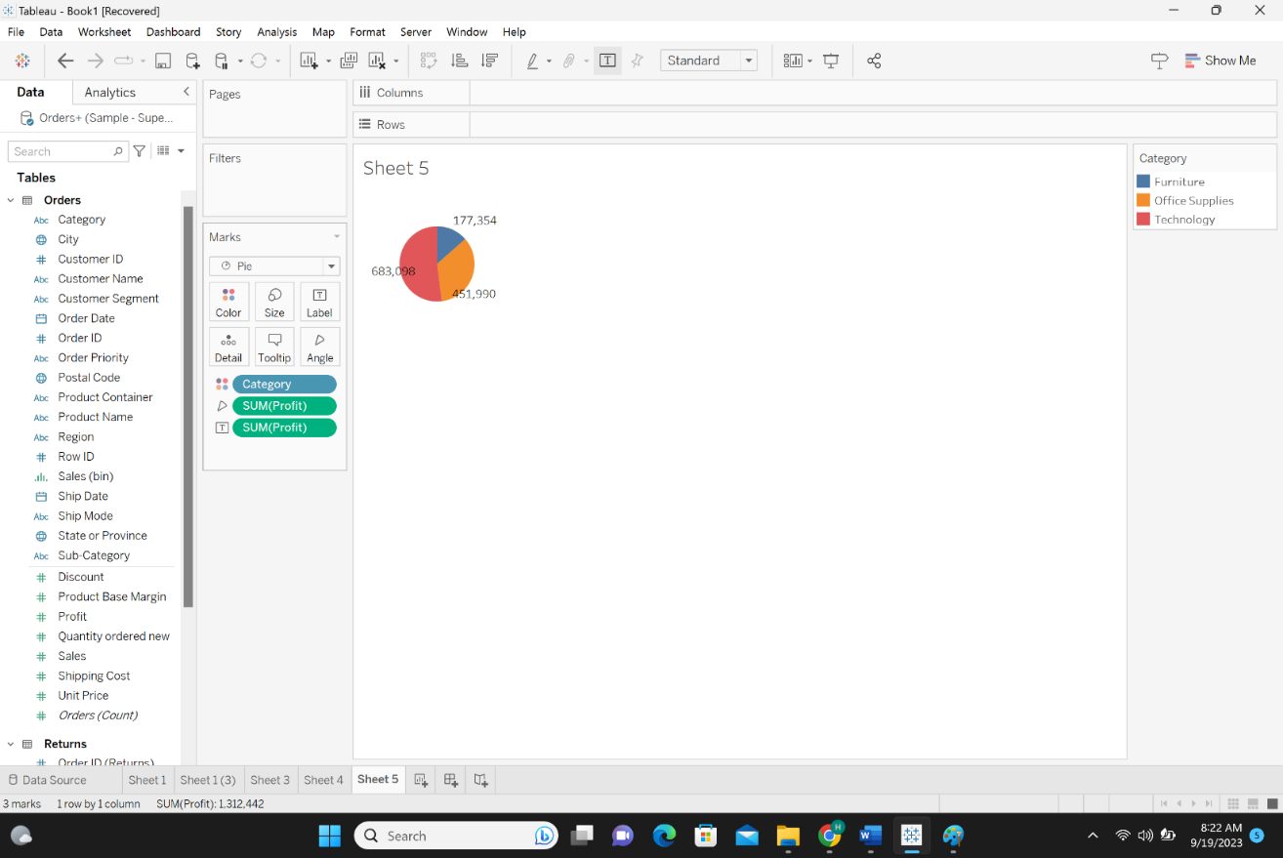
• Q6: Use Tableau to generate a “Relationship” visualization graphics and explain.
This bubble graph shows the size of sales each year. It shows the relation between sales, order year and the size of sales in that year. It shows that the highest sales was in year 2013 based on the size of the bubbles.
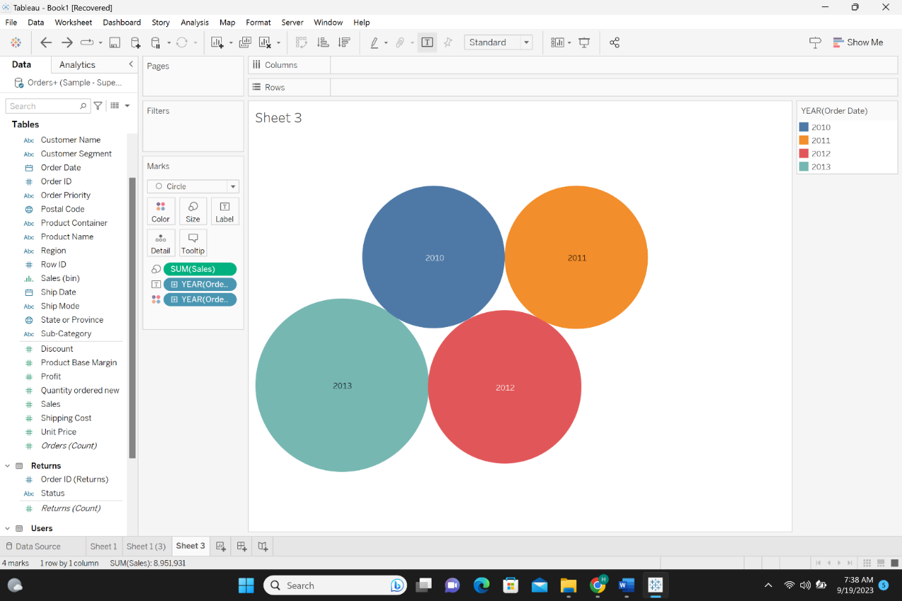
• Q7: For Comparison vs. composition explain the rational why you are not selecting alternate graphics.
I chose line charts for my comparison graph because line charts work great in comparing data points long a continuous or sequential axis which is useful for showing patterns and changes. On the other hand, I did not use pie chart because it does not provide the sequential or comparative aspect that I needed to compare the sales in different shipment modes over time. I chose pie chart for my composition graph because pie chart works best for displaying parts of a whole, emphasizing the composition of a single category in relation to the whole.
• Q8: For Distribution vs. relationship visuals explain the rational why you are not selecting alternate graphics
I chose histogram to represent the distribution of probit over different profit bins because the histograms works best for visualizing the distribution of a single variable showing how data is spread across different bins or intervals. On the other hand, bubble charts are designed for displaying the relationship between three variables (X, Y, size of the bubble). In the case above we have (sum(sales), order year, the size of sales). In a relationship graph the goal is to highlight the relationships between the data points, using a histogram would not effectively convey this information.

